1. **Agenda**:
   1. 
2. 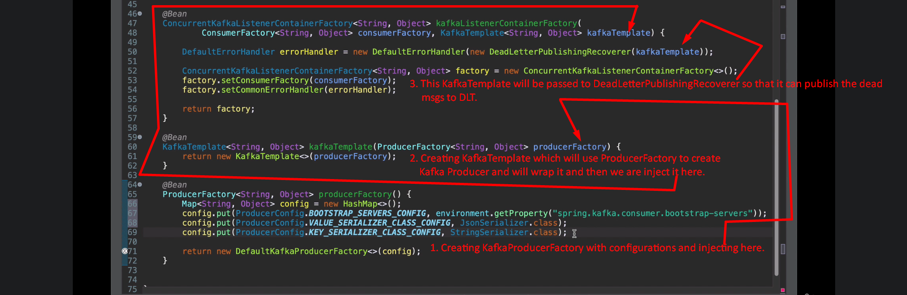
3. **NOTE**: Jatin -> Retry is performed only after msg marshalling is done successfully and exception occurs later on.